**My 10 minutes Guide**

**NOTE: for great ready to use java cucumber project I found refer to:**

<https://github.com/gopyyn/Salad#maven>

Salad - build the testing for the web-ui, rest-api and validating data in database with few

commands. It is developed using Cucumber and Selenium for Java.

**Installation**

1. Install IntelliJ Community <https://www.jetbrains.com/idea/download/#section=windows>
2. Download the project zip file [Java_Cucumber.zip](https://github.com/maorseg/java-cucumber-selenium-with-applitools/blob/master/Java_Cucumber.zip) and extract it on your PC to your favorite location
3. From IntelliJ, navigate and open the POM.xml file as maven project file

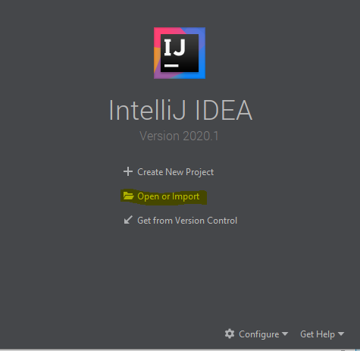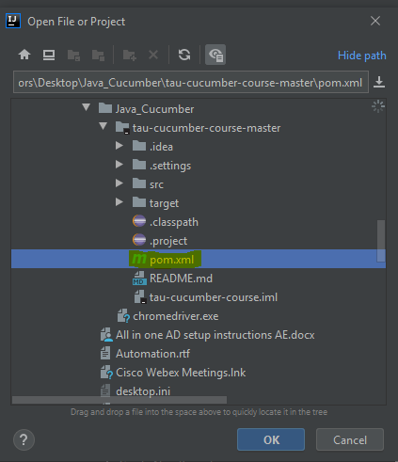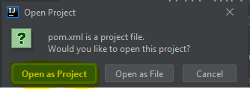

1. Install io.cucumber,Gherkin and all other suggested plugins that written in the pom.xml file

**Runnung the tests**

1. Chrome driver is included and placed next to the project folder.change in Steps @Before hook to the path you placed the driver under System.setPrperty, e.g.

// Initialize hook  
@Before()  
public void setup() {  
System.*setProperty*("webdriver.chrome.driver", "C:\\Users\\maors\\Desktop\\Java_Cucumber\\chromedriver.exe");

1. Under resources, you can run some of my existing example fetures files and add your own
2. Under Steps, you can change and add your own step defenitions i.e. Given,When,Then
3. Under runners, you can edit Cucumber test runner class to control how to run your tests e.g. run with spacific tags: tags ={"@visual"},

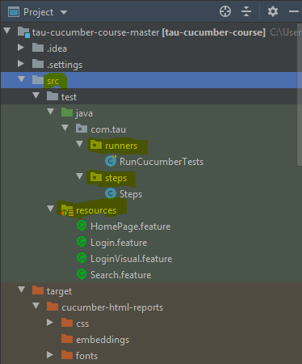

**Reporting**

1. Cucumber reporting plugin already added to the pom.xml
2. Remark the tags line in the RunCucumberTests
3. Should be like this:

glue={"com.tau.steps"},  
 features = "src/test/resources",  
// tags ={"Login","@visual"},  
 plugin = { "pretty", "html:target/site/cucumber-pretty", "json:target/cucumber.json" })

1. Expand the maven Lifcycle toolbar, Click on Verify and notice it will start to run the test cases

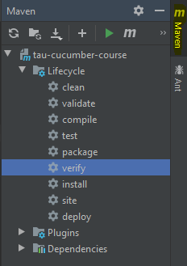

After run finished with BUILD SUCCESS

1. Go to Target - cucumber-html-reports and open in browser:

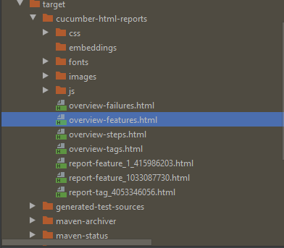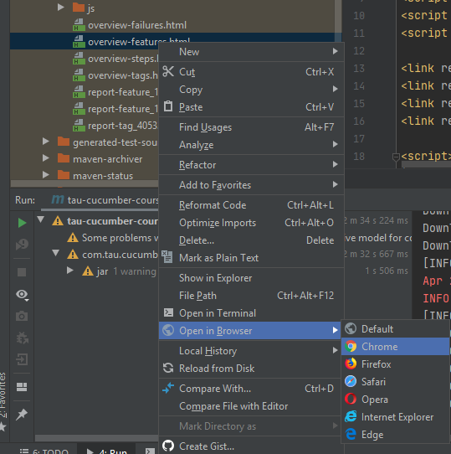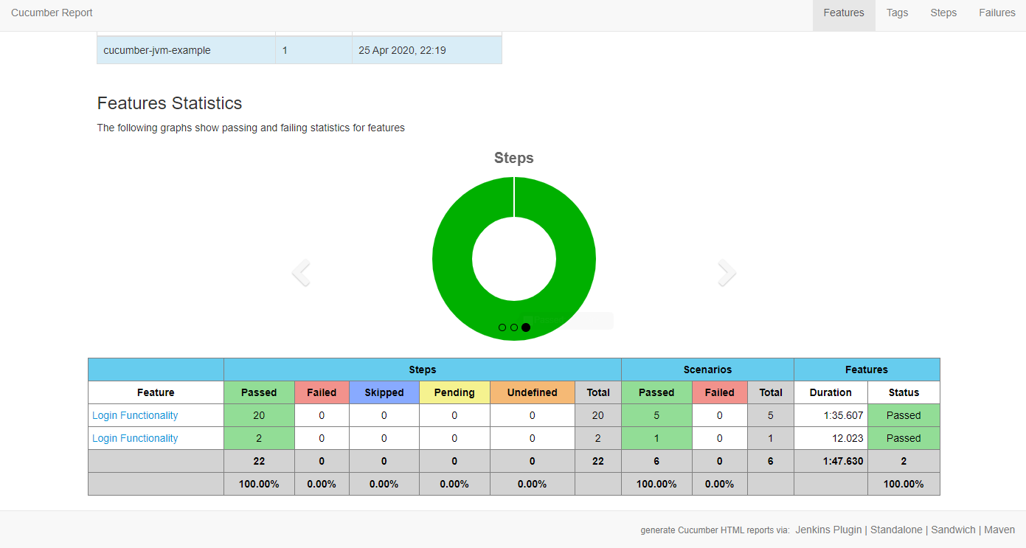

**Headless mode vs. debug mode**

In @Before hook

// To run in debug mode, enable below line:

driver = new ChromeDriver();

// To run in headless mode, enable below lines:

ChromeOptions options = new ChromeOptions();  
options.addArguments("--headless", "--disable-gpu");  
driver = new ChromeDriver(options);